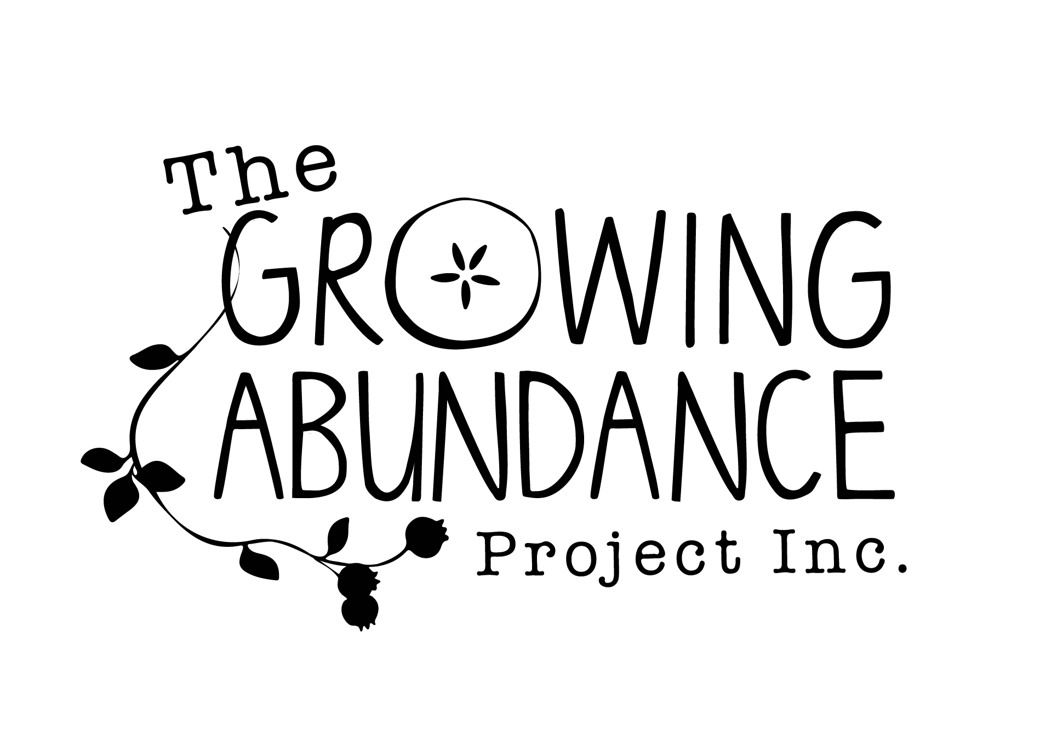
Fruit Tree Registration Form

Please note that registration of your fruit trees also involves signing
our ‘Share Care Agreement’ – available at Castlemaine Community
House or online at www.cch.org.au/growing-abundance/harvest-group

The Perks (you get):
- A 1/3 share of your fruit
- Excess fruit being harvested by volunteers and given to the local community (local primary schools, community lunch, food relief boxes etc)
- Rotting fruit (pest and disease habitat) cleaned up and removed by harvesters
- All harvested trees will be pruned in winter
- You get FREE access to all Growing Abundance fruit tree related workshops
- Warm fuzzies for sharing your backyard harvest with the community.

NOTE: We also welcome ‘unofficial’ or ‘excess only’ harvest sites with negotiable terms but we can’t insure we will be able to prune all of these harvest sites.

Date: ___________________________

Name: ________________________________________

Property Address: ________________________________________________________

___________________________________________________________________________

Do you own or rent this property? _______________________

Phone: ________________________________________________

Email: _________________________________________________

Preferred mode of communication:____________________________________

Property terrain: (checklist)
- Fruit trees on hill
- Mostly flat
- Uneven ground
- Access clear (of obstacles including steps/rocks)
- Blackberries/overgrown/long grass

OH&S Assessment:
- long grass
- potential trip hazards
- ladder on site (that is well functioning)
- Owner willing to let harvesters use ladder?
- Animals onsite? eg: dogs

Brief history of the site (i.e how long have you owned it, has it been farmed etc?):

Do you want to assist us with harvesting? Y/N

Do you want a 1/3 share of fruit harvested? Y/N

Are you interested to attending maintenance workshops? Y/N
(i.e pruning, natural pest control etc)?

How/when can we access your property to harvest?

Are you able to let us know 2-7 days before the fruit needs harvesting? Y/N

Is there a toilet easily accessible to harvesters? Where?

Do you have any ladders or tools on site that harvesters can use? If so what?

Have you read the ‘share care agreement’ and agree to the terms?

- Yes
- No- I want to be an ‘unofficial’ harvest site

Signed Share Care Agreements can be delivered to -

Harvest Coordinator
Castlemaine Community House at 210/212 Barker st
Posted to PO Box 386, Castlemaine 3450
Or emailed to: harvest@cch.org.au
Thank you!

Number and type of Fruit trees:
Quantity | Type | Age | Height | Condition & Health of trees/ Quality of fruit  Pests and diseases; e.g. curly leaf, codling moth; fruit, leaves | Any sprays or treatments used  E.g. Bordeaux, copper, pesticide, herbicide | Date usually ripe

