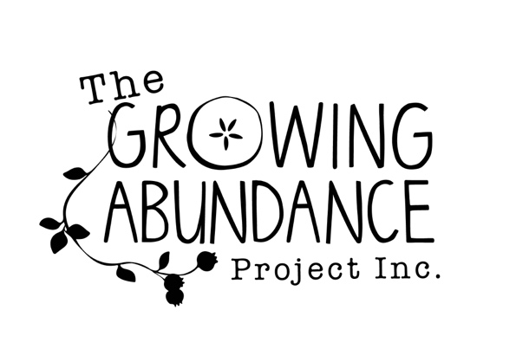
Dear wonderful person who is the owner or carer of fruit trees,
Thank you so much for your interest in the Growing Abundance Harvest Group. This is a part of the Growing Abundance project. Harvest aims to reduce Castlemaine’s carbon emissions and promote community resilience by creating a stronger local food network, making links between the local people who are growing food and the people who want to eat it. This way we can use the abundant food that is grown and produced locally and rely less on food that is trucked in from hundreds of kilometres away. This has many benefits for the local community and the environment.
Every year in our area, hundreds of fruit trees growing on both public and private land go unharvested. This is a source of local food that is mostly wasted.
The Harvest Group aims to link up local people who have fruit trees with a team of volunteers who can harvest and re-distribute a share of the fruit to the local community. The harvest volunteers will also be trained in basic fruit tree maintenance such as pruning, mulching and composting and will return in autumn or winter to those trees which are harvested to maintain them and ensure abundant harvests for many seasons to come.
The purpose of the attached Share Care Agreement is to ensure that we are all clear about how the project will run and that our relationship continues to be a mutually beneficial one into the future. Thanks again for your involvement, and please don’t hesitate to contact me if you have any questions.

The Harvest Team

harvest@growingabundance.org.au
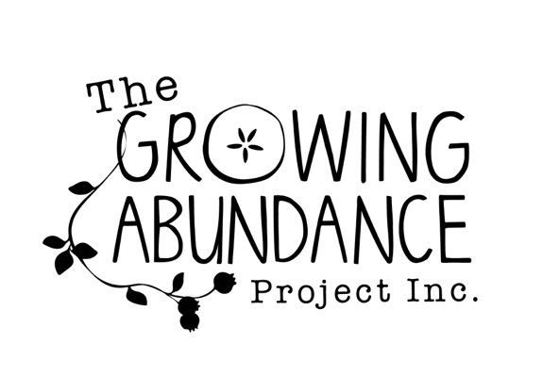

I .....................................................................................
(Property owner name)
of ...........................................................................................................(Address) agree to and understand that:
- In return for 2/3 of the fruit from my tree/s (which will be distributed to volunteers and other community organisations), Growing Abundance (GA) will provide harvest volunteers to harvest, clear windfall fruit, prune and maintain my fruit trees using organic methods.
- If I want it, I will receive a 1/3 share of the fruit from my tree/s.
- I will phone or email the Harvest Coordinator when I judge that the fruit on my tree/s are almost ripe so that we can organise a date and time for the volunteers to come and harvest.
- The Harvest Coordinator will contact me at least two days in advance to organise access to my property for harvesting and maintenance of fruit trees by volunteers.
- Growing Abundance volunteers are covered by the Growing Abundance Project insurance policy; however, I will remove any dangerous occupational health and safety risks from the site to ensure the safety of community harvest volunteers. This includes long grass and trip hazards.
- I understand that all GA Coordinators and Harvest Supervisors have current police checks and Level 2 First Aid training; and that at each harvest a first aid kit will be provided by GA.
- All volunteers attending a harvest will have photo ID which can be produced upon request of the land owner.
- Should there be any concerns with the Harvest Program, they can be discussed with the Harvest Coordinator or GA Coordinator through contact by ph: 0405663496 or email: grow@growingabundance.org.au
- I understand I can stop my involvement at any point by letting the Harvest Coordinator or GA Coordinator know that I wish to do so.
- Signed:
- Fruit tree owner

- Signature ………………………………………………….

- GA Harvest Coordinator

- Signature ............................................

- Date....................

