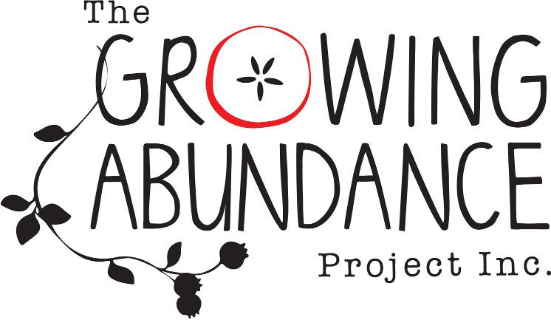

Annual General Meeting

Thursday 24 November 2021

“Local Food, No Waste”

Time: 7pm
Location: Online via Zoom
Present:

Apologies:

Chairperson: Madeline Hudson

Notetaker: Grace Nicol

ITEM
- Acknowledgement of Country
- Minutes of previous AGM - acceptance of minutes of previous AGM
Motion: Minutes of 2020-21 were true and accurate record of the proceedings
  - Moved b. Seconded
- Chairperson's Report (Madeline Hudson)
- Moved b. Seconded
4. Treasurer's Report (Keppel Cassidy)
a. Moved b. Seconded
5. General Business

5.1 Election of Committee Of Management (CoM)
5.2 Election of Public Officer

6 Next Steps
6.1 Next Committee Meeting - suggested date Thursday 2nd December 2021 -
dependent on availability of CoM members - handover and 2022 planning

