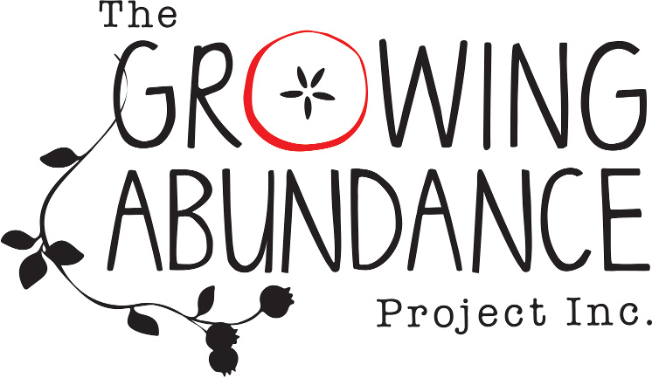

Membership Application

I wish to apply to become a Member of The Growing Abundance Project, Incorporated.
I support the purposes of the Association and agree to comply with the Rules of the Association*

Signed:

…………………………………………………………

Name:

Address:

Email contact:

Phone:

Please return by email to hello@growingabundance.org.au

*Being based on the Consumer Affairs of Victoria Model Rules of Association and adapted to TGAP.

