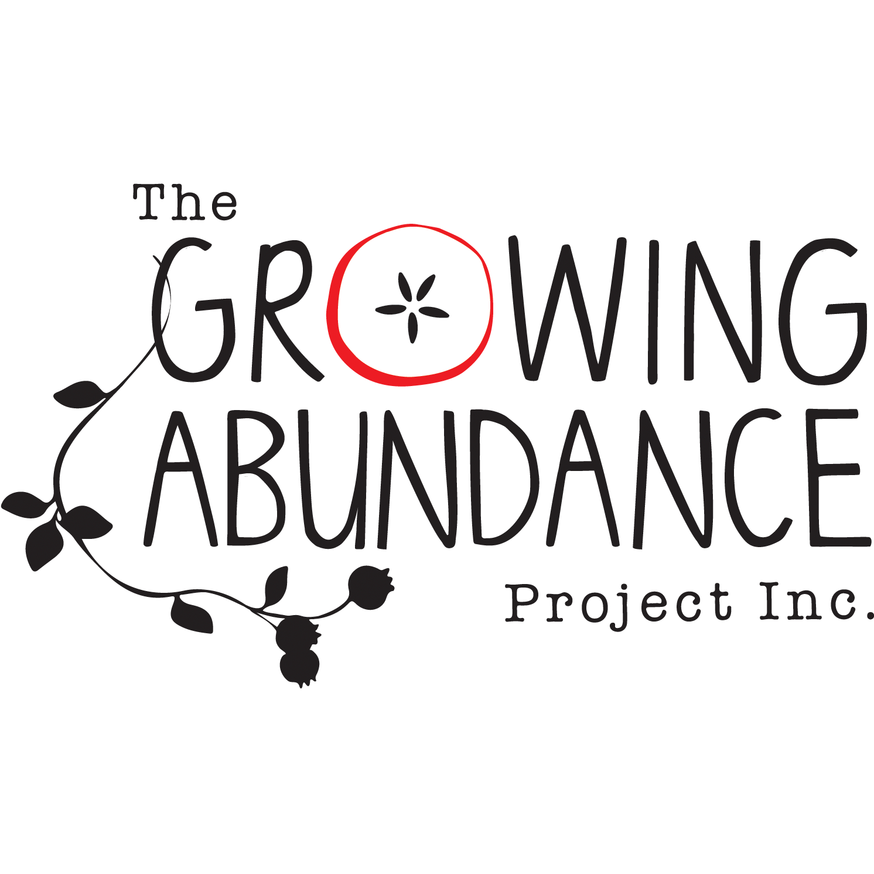
APPOINTMENT OF PROXY FOR
ANNUAL GENERAL MEETING (AGM)
24 NOVEMBER 2022

I ____________________________________________ (my name)
of____________________________________________ (my address)
being a member of The Growing Abundance Project Inc appoint
___________________________________________ (name of proxy holder)
of _________________________________________ (address of proxy holder)
being a member of that incorporated association, as my proxy, to vote on my behalf.
__________________________________ (my signature)
__________________________________ (Date)
This form must be shown to the Chairperson of the AGM before or at the commencement of the AGM.
Growing Abundance
hello@growingabundance.org.au
PO BOX 857
Castlemaine VIC 3450
Australia

