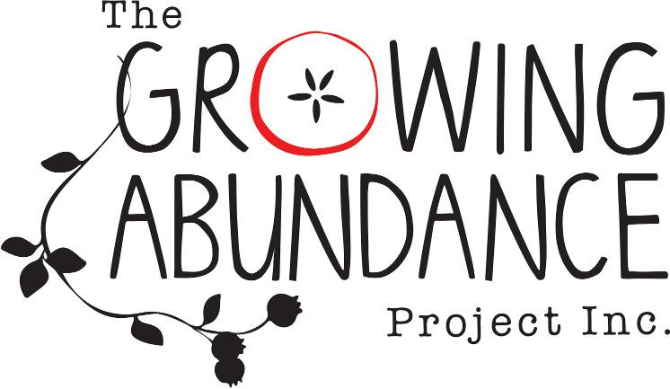

Annual General Meeting

Thursday 14th December, 2023

“Local Food, No Waste”

Time: 6pm
Location: The Hub Plot, cnr Barker and Templeton St Castlemaine
Present:

Apologies:

Chairperson: Ruby Carrodus

Notetaker: Grace Nicol

ITEM
- Acknowledgement of Country
- Minutes of previous AGM
Motion:
  - Moved b. Seconded
- Chairperson's Report
- Moved b. Seconded
4. Treasurer's Report
a. Moved b. Seconded
5. General Business

5.1 Election of Committee Of Management (CoM)
5.2 Election of Public Officers

6. Next Steps
6.1 Next Committee Meeting

